
DEPARTMENT OF COMPUTER SCIENCE
CSC 518

Due Date: 2 May 2024
Group 4 Members:
XANYWA S 202125763
MONI S 202016734
MJIKELISO S 202001421

Problem 4: Education Problem

A predictive tool to provide personalized recommendations and support to GRADE 12 learners.

- The obstacles that students in the Eastern Cape Province must overcome to succeed academically include a lack of drive, restricted book access, inadequate instruction, learning disabilities, and bad study habits. One game-changing approach could be to create prediction tools that use machine learning and data analytics to offer individualized advice and assistance. These technologies can provide insights into the underlying reasons of issues, as well as customized study materials, exercises, and motivating messages, by assessing past performance and behavior. This method seeks to meet the individual requirements of students, improve their educational experience, and eventually raise their academic performance. Predictive technologies have the potential to empower students, lessen obstacles, and create a more favorable learning environment in the Eastern Cape Province, which is why this problem was chosen.
- The key factors that influence our problem mostly are Age, Study time, Attendance, Teacher (Assistance), Previous exam scores (Science majors).
- The Random Forest algorithm is a good option for creating prediction tools to address the difficulties experienced by students in the Eastern Cape Province. Known for its accuracy, efficiency with huge datasets, resistance to overfitting, and capacity to accept multiple input variables without requiring variable elimination, Random Forest is a flexible classification technique. Because of its prowess in building models from historical data, this algorithm is perfect for examining learners' prior performance and behavior in order to offer tailored recommendations. Furthermore, the intricacy of educational data and the requirement for accurate insights to help students overcome their academic obstacles are well matched with Random Forest's ability to estimate significant factors in classification and manage missing data well.

Process for developing the predictive tool:
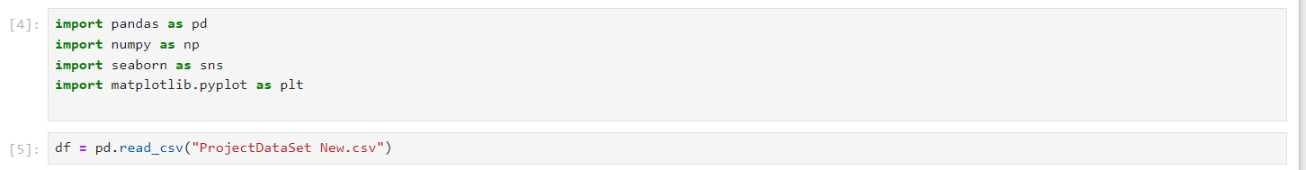
Figure 1Importing necessary libraries for loading the dataset file.
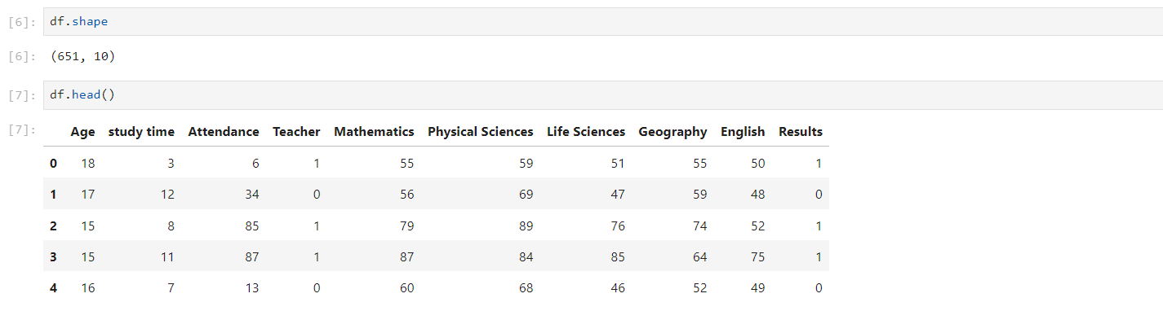
Figure 2 Displaying a sample of our data to show successful loading of dataset to the data frame in the workspace.
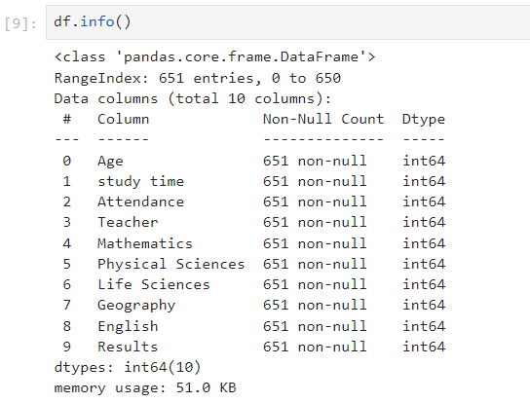
Figure 3 Checking for empty cells in the dataset.

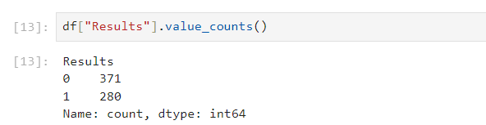
Figure 4: Counting the number of passes and fails.
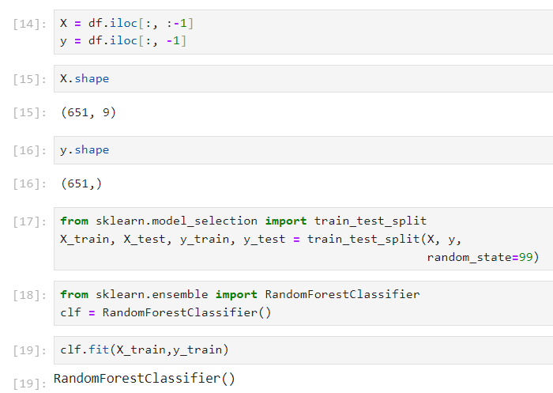
Figure 5: This is the training phase of the Random Forest Model.
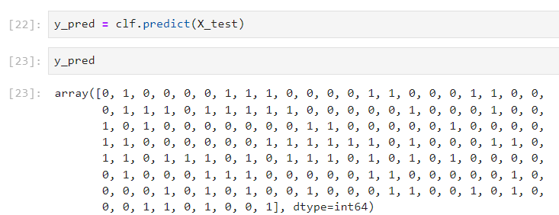
Figure 6: Predicting the results from the X test variable to test the model.

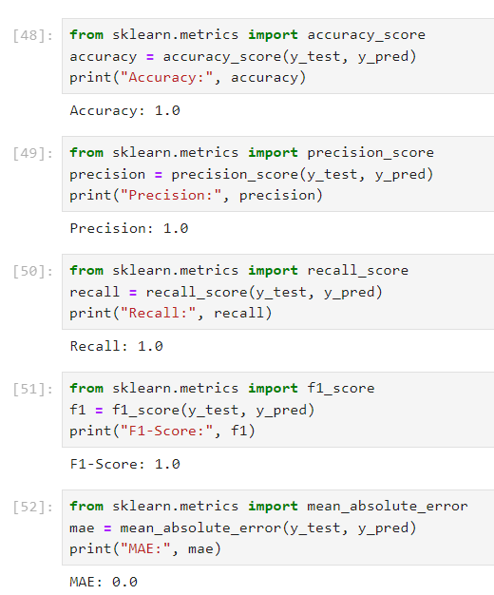
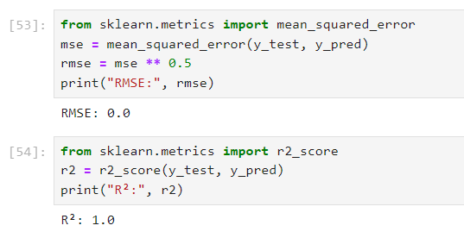
Figure 7: Testing the model for Validity using the validation metrics.
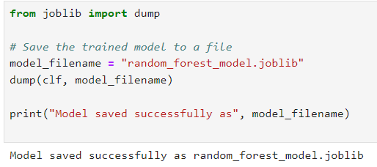
Figure 8: Saving the Random Forest Model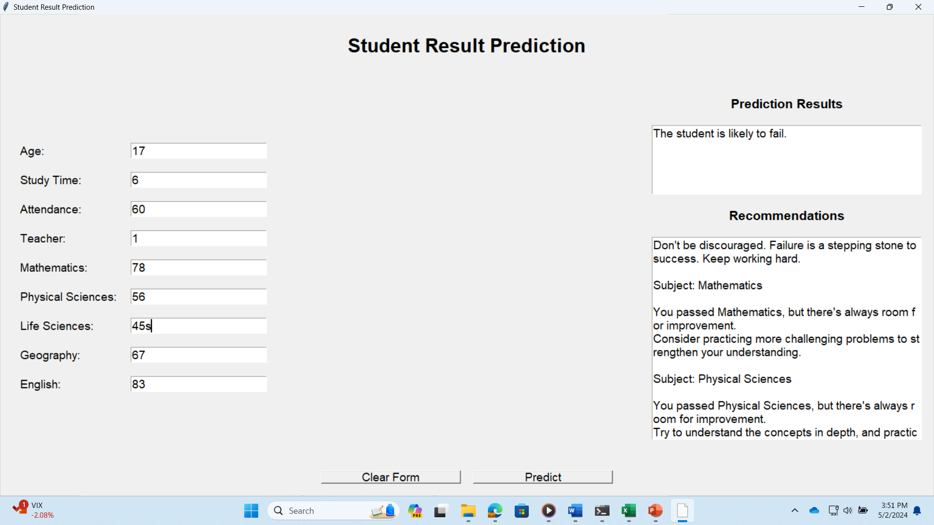
Figure 9: Working Prototype

